

Practices for Secure Software Report

Table of Contents
Document Revision History 3
Client 3
Instructions 3
Developer 4
1. Algorithm Cipher 4
2. Certificate Generation 4
3. Deploy Cipher 4
4. Secure Communications 4
5. Secondary Testing 4
6. Functional Testing 4
7. Summary 4
8. Industry Standard Best Practices 4

Document Revision History

Version | Date | Author | Comments
1.0 | 2/18/2026 | Austin Freeman | Initial

Client



Instructions

Submit this completed practices for secure software report. Replace the bracketed text with the relevant information. You must document your process for writing secure communications and refactoring code that complies with software security testing protocols.

- Respond to the steps outlined below and include your findings.
- Respond using your own words. You may also choose to include images or supporting materials. If you include them, make certain to insert them in all the relevant locations in the document.
- Refer to the Project Two Guidelines and Rubric for more detailed instructions about each section of the template.

Developer
Austin Freeman

Algorithm Cipher

- Provide a brief, high level overview of the encryption algorithm cipher.

For this program, I recommend using AES-256/GCM. AES-256, when combined with GCM, provides a way to detect when information has been intercepted or modified. Given the sensitive nature of the information, it’s important to prevent poisoned or malicious content from reaching the codebase or internal servers. This encryption also allows us to comply with local data security regulations without bogging down servers with complex encryption algorithms. The 256 in AES-256 refers to the key size, making this encryption strong and resistant to brute-force attacks. The GCM portion provides a degree of certainty about the integrity of out data by serving as a flag for malicious or intercepted data.

- Discuss the hash function and bit levels of the cipher.

AES-256 can be used with TLS 1.3, which supports a variety of hash algorithms. For this example, I recommend using SHA-256 because it is widely used and offers strong collision resistance. This provides us with a level of security that can’t be achieved with something like SHA-1 or MD5, given the likelihood of collisions. SHA-256 produces a 256-bit hash for authentication, while AES-256 uses a fixed 128-bit block size, and GCM adds a 128-bit tag to verify data integrity.

Together, these encryption methods provide a high level of certainty about the information being used. Breaking AES-256 is functionally impossible give our current processing capabilities, and SHA-256 provides a secure method for generating digital signatures and helping in key derivation while avoiding collision. When used together, decryption of sensitive data is almost impossible without a common vulnerability or poorly managed keys.

- Explain the use of random numbers, symmetric versus non-symmetric keys, and so on.

Modern encryption relies on the usage of random numbers, and in the example of AES-256, this is even more important. The usage of random numbers to generate unique nonces for encryption keys and initialization vectors is key to secure encryption. It’s important to use truly secure random number generation that relies on system entropy rather than a standard random number class. Classes like SecureRandom are highly recommended because they use a random number generation method that reduces the likelihood of patterns emerging.
We have two types of encryption available to us, symmetric and asymmetric. In symmetric encryption, a secret key is used for both encryption and decryption. Symmetric encryption is generally best for large amounts of data because of its efficiency, making it a great choice for applications. Asymmetric encryption is a tad different, things like RSA are a great example of this. Using concepts like modular exponentiation, we are able to use two different keys, one for encryption and one for decryption. This method allows us to pass information between two individuals using a secure, authenticated connection. Things like public keys can be exchanged, and a symmetric encryption can be established. Asymmetric makes symmetric encryption and key sharing much easier.

- Describe the history and current stat of encryption algorithms.
Depending on where you look there are numerous examples of encryption and encryption algorithms throughout history. Whether we point to the encryption cipher used in ancient Rome, the Caeser cipher, or to a more recent example like the Enigma machine used by the Axis powers during World War Two, each has a long history. Modern encryption, as we recognize it today, dates back to the 1970’s. Initially known as the Data Encryption Standard (DES), this method became the gold standard for encryption. As advances in computing and mathematics improved our ability to process information, we found the need for an updated standard. In the early 2000s, we adopted the Advanced Encryption Standard (AES), which provided better security and larger key sizes. Additions to this standard introduced GCM, which gave us confidence in the information exchanged between entities and enabled us to detect tampering. Today, encryption has become a game of cat and mouse. Modern methods allow for the use of more complex algorithms and help ensure that key management and authentication go smoothly. Modern ciphers with adequate key sizes are difficult to decrypt without large amounts of processing power. The biggest risk to modern encryption is no longer the math, it’s the people.

Certificate Generation

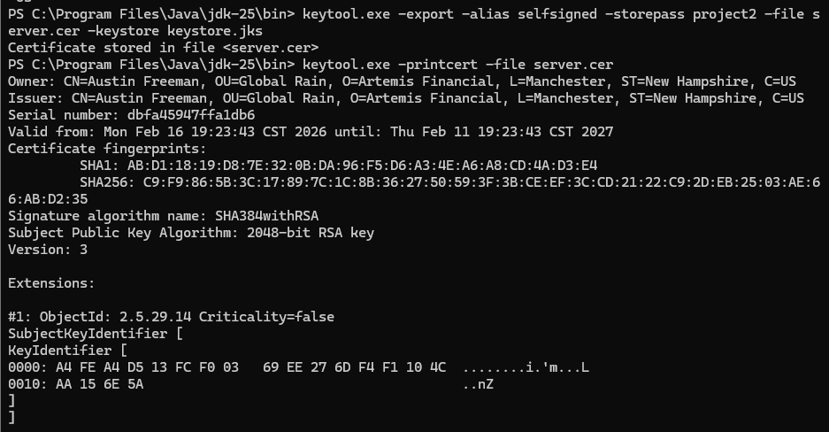

Deploy Cipher
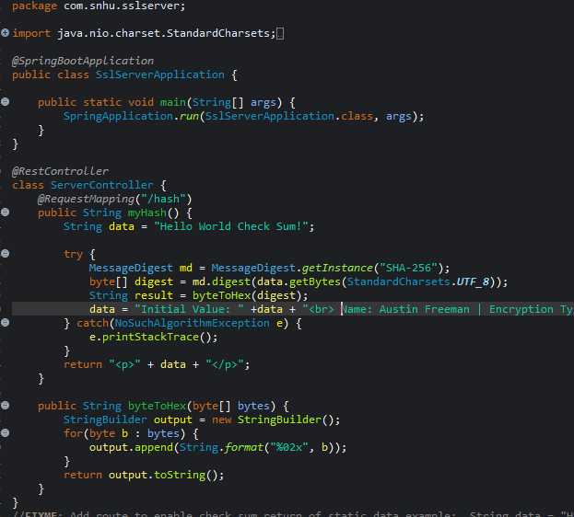

Secure Communications
Insert a screenshot below of the web browser that shows a secure webpage.

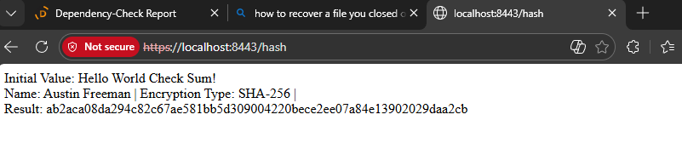

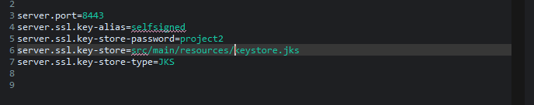

Secondary Testing
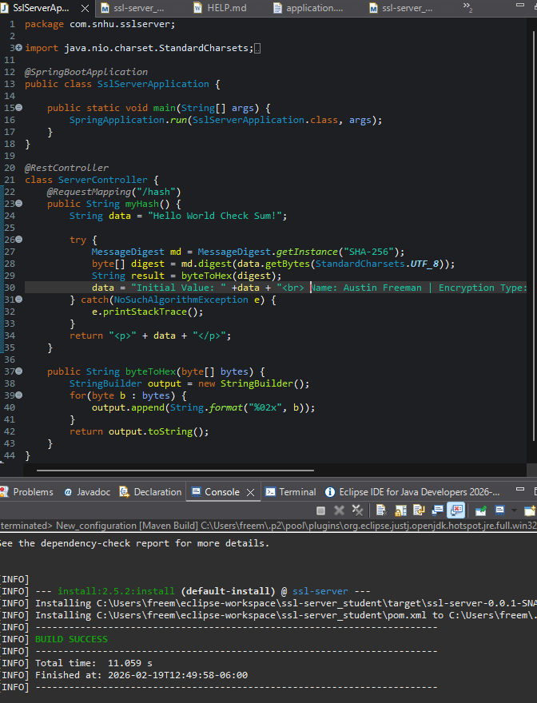
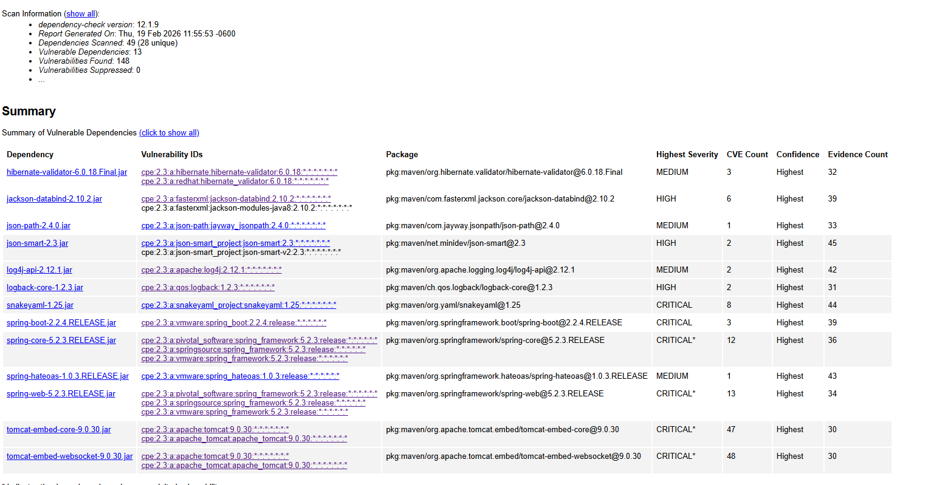

Functional Testing

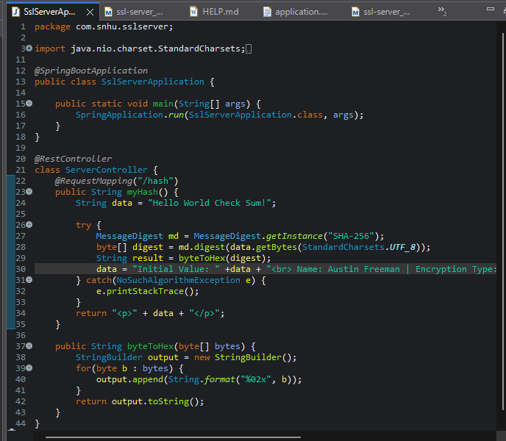

Summary

For this application, we were asked to address data protection and secure communications when using the dependency check tool, ensuring that these alterations didn’t introduce new issues. We started our refactoring by updating the dependency-check tool, doing so gave us access to the most recent CVE list for our code. After this, we ran a simple Maven install and generated a dependency check to use for verification once we completed our refactor. This gave us a solid baseline for comparing results. Looking into what we’ve been asked and the deficiencies in the codebase, we saw that cryptography needed to be addressed, as well as ensuring code quality was maintained. We started by looking into our options for ciphers. A few of them seemed appropriate, but AES-256/GCM continued to stand out to me as a solid choice for both encryption and security. Since we were also interested in hashing, and the usage of TLS 1.3 seemed implied, we used SHA-256 as the hashing algorithm. Each of these encryption options offers strong protection and confidence that our data hasn’t been tampered with. We had the choice of encryption down and could move on to generating the certificate needed to accomplish this. Using keytool, we generated a self-signed certificate that our program can use. After that, we export the certificate and keystore to our project's file and update the application properties file to use them. Doing this enables HTTPS rather than open HTTP. This gave us stronger resistance to man-in-the-middle attacks and made any intercepted data essentially useless. After this, we refactored the code to implement a cryptographic hash algorithm, enabling checksum verification. Finally, after all is said and done, and our checksum has been successfully completed, we ran another dependency check. We use the first dependency check compared with our second to ensure that our refactoring didn’t introduce any new vulnerabilities. Once it was clear that we hadn’t introduced anything new and were certain our alterations improved security our job was complete.

Once everything was done, and dusted, we had created and implemented a security protocol that could secure data in transit while also protecting data integrity through the use of cryptographical hashing, the usage of authenticated endpoints, and the security scanning using a third-party dependency check tool. These changes reflected the seven pillars of proper vulnerability assessments, and allowed us to implement changes that bolstered security rather than lower it.

Industry Standard Best Practices

Throughout the refactor, we followed industry standards to prevent the introduction of new vulnerabilities. By using secure coding practices and authentication, we created a program that was more secure while avoiding the common pitfalls that can arise from code refactoring. We implemented HTTPS, introduced a cryptographic hash for data integrity, and used third-party dependency-scanning software for static analysis. Each of these small alterations improved the program, and we know this because the first dependency check mirrored the final one.

The value of applying industry-standard best practices to a company’s overall well-being isn’t immediately apparent, but by using them, we can avoid common vulnerabilities and adhere to strict regulatory requirements. By using this proactive approach, we can also avoid data brea
ches and limit the risk of common attacks. This creates an environment where users can trust the application, and the company avoids the financial risks commonly associated with data breaches or regulatory action for poor practices

